Viking GPS Manager: JPEG Map imports.

Preamble
I'm a sailor and I use the wonderful Viking software as the core of a fabulous Chart Plotter. Grateful thanks to all the developers of Viking! If this fork seems to be useful to a few people, and if the good folks at Viking are interested, I'll beautify the code and perhaps they will merge it into Viking mainstream.
The JPEG File Import module has been developed and tested only in the northern hemisphere and only in Ubuntu Linux V9.04 and V9.10. It has not been tested with mapping for regions south of the equator. You'll find that there is further mention of charts in the software and in this document. That's just the way it is, sailors call maps “charts”, maps and charts are the same thing.

JPEG File Import Module: Notes and usage
The JPEG File Import Module makes possible the importing of a JPEG formatted map image into the Viking map cache. The map can then be displayed in the Viking viewport in the same way as any other map type that Viking supports. Viking can properly align and calibrate your map. The manner by which the Import Module is invoked will be familiar to frequent users of Viking.

Before you start
You will need to install and run the JPEG fork made from Viking V0.9.9. You will find the source code accompanying this document. Build it as instructed on the Viking Web Site. You MUST check with the laws of your own country to be sure of the conditions under which you are entitled to copy on copyright material. Do not break the law!
You will need to prepare your map file (I find the GIMP to be an excellent tool for preparing my maps):
    - The map must be in Mercator projection. Other projections can be imported but may show serious placement errors, especially in the case of large scale maps, e.g. a map of the entire US.
    - The map must be rectangular, but may be any aspect ratio.
    - It must be “upright”. Viewed on a monitor the North West corner will be at the top left of the image, the South East corner will be at the bottom right. Same for both north and south hemispheres.
    - It must be exactly “level”. That is, viewed on a monitor, lines of latitude are exactly horizontal and lines of longitude exactly vertical.
    - You must know the scale of the map (e.g. 1:50000).
    - You must know the resolution of the map in Points Per Inch (p.p.i. e.g. 150).
    - You must know the coordinates of the map origin (North West corner e.g. N 43deg 15.00min, E 5deg 07.00min).
    - You must have a clearly defined point near to the South East corner of the map ( a so-called Yeoman point). This is so that Viking can calibrate the map for you (adjust the horizontal and vertical scaling).

Using the JPEG module
Start Viking and add a new map layer (Using the menus, select “Map”, then “New Map Layer”). In the “Layer Properties” window that appears:
- select “JPEG Import”.
- Choose a folder in which you wish to place your imported maps. It's recommended that this should initially be a temporary folder e.g. “~/Desktop/tempcharts”.
- Keep the Default setting for Alpha (255)
- Keep the Default setting for Autodownload maps (unchecked)
- Keep the Default setting for Zoom Level (use Viking Zoom Level).
- Click on the OK Button.
A new map entry labelled “Map” will be seen in the Layers Panel (at left). You might wish to rename this to something more meaningful (“Test1”?). Right click on this entry and then select “Download Onscreen Maps”.
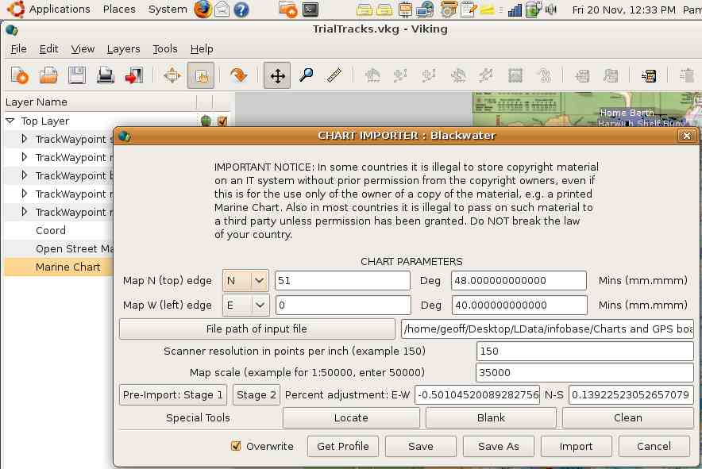
The Chart Importer dialog box will appear. On the first occasion this window is seen it will only show the current coordinates of the Viking viewport center mark and your home folder path.

Using the Chart Importer Dialog
You are now ready to start the import procedure. First of all we are going to prepare and save a “Profile” for your map image. That is we will make a sufficient description of the map so that Viking can properly size and position the map at any zoom level.
- For now click away the dialog by using the “Cancel” button. Place the Viking Viewport in the locality of the map that you are about to import. (Say at the origin of your map (north west corner).
- For your first trials – select a fairly high zoom (e.g. for an A3 map at 1:100000 scale and having 150pp a suggested zoom is 64). The reason for this is that if you zoom in too low you are likely to generate huge numbers of pixels. If you have zoomed too far in (the closest in that you can go is to a zoom=1) you will get a warning that this is going to happen and an opportunity to cancel.
- Invoke the Chart Importer Dialog again by right clicking on the Map entry and selecting “Download Onscreen maps”.
- Enter the coordinates of the map origin (North West Corner).
- Click on “File path of input file” button and use the File Chooser Dialog to select your jpeg file for import.
- Enter the ppi (typically the setting on your scanner e.g. 150)
- Enter the map scale (typical hiker's maps are 1:25000. This means that 1 cm on the map is 250 metres “on the ground”)
- Click on the “Pre-import: Stage 1” button. You probably don't want to keep entering the above data, so click the “yes” button on the “Profile Data” dialog that appears and then choose a file to save the data into using the file chooser.
- After a short while (or perhaps a bit longer if you have zoomed in too close!) the dialog will disappear and the entire map should appear in the viewport.
- Now we'll calibrate the map. IMPORTANT: Scroll the image and place the viewport center mark on the apparent position of the Yeoman point that you prepared near to the South East corner. I write “apparent” because it's likely at this stage that the map has some sizing errors and in reality the point is somewhere nearby. If you have a 3-button mouse then click on the mark with the center button to accurately place the mark.
- Again show the Chart Importer Dialog. This should now be filled with the previously entered interim profiling data.
- This time click on the “Stage 2” button. The “Chart Resize” dialog appears. Viking has tried to guess the coordinates of your Yeoman point - enter correct values if the app got it wrong!
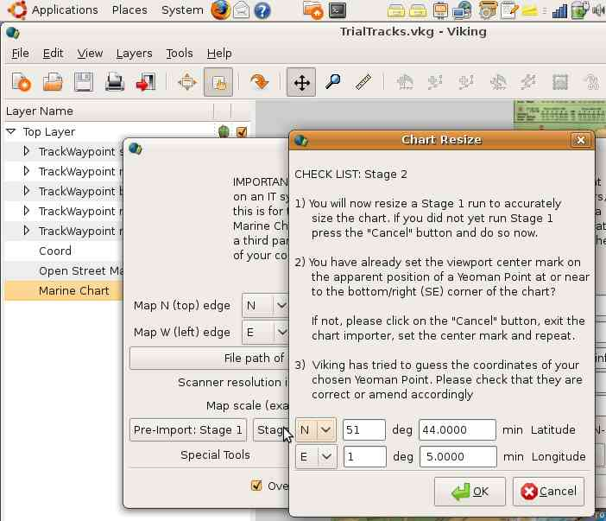
- Click on the OK button to complete the procedure and again answer “yes” to save the updated (definitive) profile. The Stage 2 procedure corrects, indepen-dently, first order errors along the latitudinal and longitudinal axes. These might be up to several percent if your artwork started on paper. The map reappears, possibly in a slightly different position showing that the scales have been calibrated and the saved profile now accurately describes the map image.
- If the profiling was successful at the high zoom level you used for your first test you might like to zoom in a bit a try a second test repeating the above steps. This will improve the accuracy of your profiling and the correction of scale errors.

Problems?
You didn't see any map image? Me too – many times! Check that:
- You are still set on the Zoom level used during the Pre-importing.
- The viewport is set to a latitude/longitude where you can expect the imported map to be visible.
- All the figures that you entered into the Chart Importer dialog are correct. If you find errors restart the procedure.

Checking for mapping accuracy
Add a “Coord” layer to the map and make the Viking generated coordinates visible (default). Check that the coordinate lines generated by Viking exactly coincide with any coordinate lines printed on the map. If there are locations on the map with known coordinates use the mouse pointer to confirm that their positions are correctly shown by Viking. You should check all corners and the center of the map to make sure that it has been placed accurately. The accuracy of map placement and the size of subsequent mapping errors is absolutely dependent upon the care taken with the procedures above. No responsibility can be accepted by the author for any consequences resulting from the use of this software (See also the GNU Copying and Software License which accompanies this document.)

Production Stage
You can now import the map into your main Viking map cache (probably in “~/.viking-maps”, the default folder) at all zoom levels possible/required. JPEG imports will not overwrite any other map types that you have in the cache. So start by selecting your main cache in the Properties window (right click on the JPEG map entry in the Maps panel – the one you created in this exercise - select “Properties” and click on the “Browse” button.)
As you zoom in the number of pixels generated during the import process dramatically increases. You will start to get warnings when the pixel count exceeds 50 million. You can try importing after a warning to see what happens but the import may be lengthy and might fail.
At each zoom level invoke the Chart Importer Dialog box using the same procedure. Providing that you answered “Yes” each time during the Pre-Import procedures, Viking will reload the profile data that you saved and all that you have to do is click on the “Import” button. If you also check the “Autodownload maps” check-box in the Properties window, then when you change zoom the Chart Importer Dialog box will automatically reappear at the new zoom level. Don't forget to cancel the check when you have finished importing!

There's more! . . . .
….. but I haven't time at the moment.

Geoff Childs
Document V 0.1
20/11/09

